Red_Dawn
- Ship's Master
- 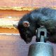
- Member

- 120 posts
- Gender:Polly Wanna Cracker
- Location:Southern AZ
- Interests:A bit varied.
Posted October 31, 2011 · Report post
I asked this on a writers' forum, but while I got some good info on the subject, I don't feel like I have enough info.
I'm looking for rude gestures from the Golden Age. The kind you could get away with in a PG movie, but would get you in trouble with your mom if she caught you using them. For example, I know about the two-finger salute, but not what it was called back then. I also know about the bras d'honneur, but neither how old it is nor what it would've been called if it had existed back then. Anyone else know? (If I'm wrong about how PG those gestures are, let me know that, too.)
I'm also open to suggestions for other easily described, PG gestures, especially English and French. I'm looking more of the Up Yours variety, but the Neener Neener will do. Thanks!
P.S. Yes, an upraised middle finger is ancient. Yes, I've seen it in a PG movie. It just doesn't feel right for a Caribbean-type pirate story.

Grymm
- First Mate
- Member

- 281 posts
- Gender:Male
- Location:Chilterns UK
- Interests:Stuff
Posted November 1, 2011 (edited) · Report post
Which 2 finger salute? If you are thinking about the 'Archers salute' the idea that it's from Agincourt is a 1960/70 construct, as an offensive gesture it's certainly at least 17thC (His wife … Behind him forks her fingers. Sir John Mennes and J. Smith, Witts Recreations, 1640) but possibly as an adaption of The Cuckolds Horns, which is extending the fist with the forefinger and pinkie extended and the middle fingers doubled in( think the 'devil horns ROCK N FLIPPING ROLL!' symbol against your forehead), which implies that the person being insulted is a cuckold or their Missus does favours for sailors =o)
He would have laine withe the Countess of Nottinghame, making horns in derision at her husband the Lord High Admiral. (Sir E. Peyton, The Divine Catastrophe of the … House of Stuarts, 1652)
Here is Idleness doing it to the chaps taunting him with a noose.
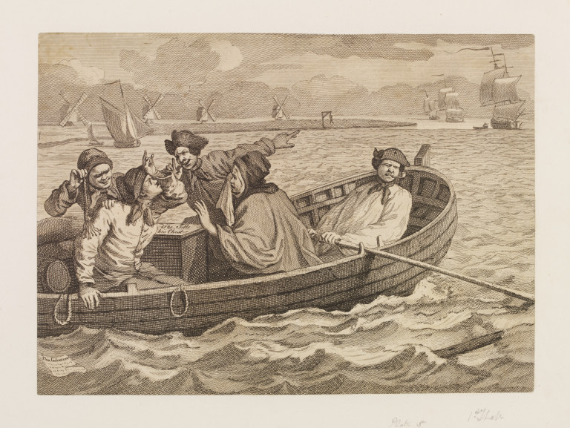
Then there's the flicking the thumbnail with the teeth 'Biting your thumb' from Shakespear "I will bite my thumb at them; which is a disgrace to them, if they bear it."
It could also be 'to give the fig', also the fig of Spain and to give the fico. The fig or Italian fico involves putting the thumb between the first two fingers or in the mouth. The French and Spanish phrases for it are faire la figue and dar la higa respectively.
Mooning goes waay back too, Medieval
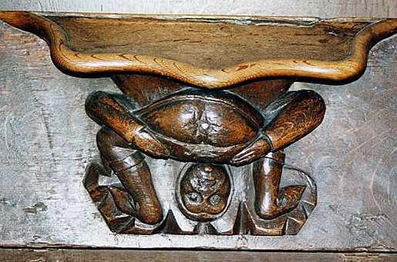
Early 18thC (In the window above the black clad religeous types)
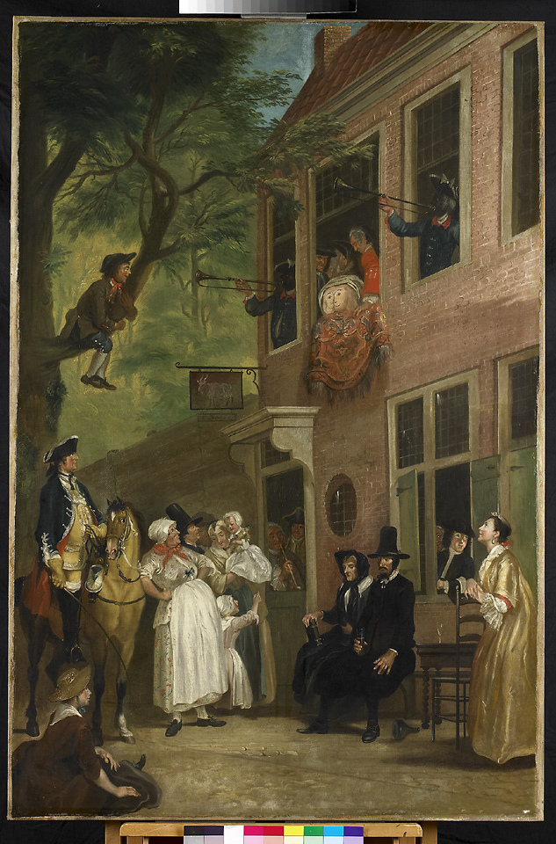
19thC
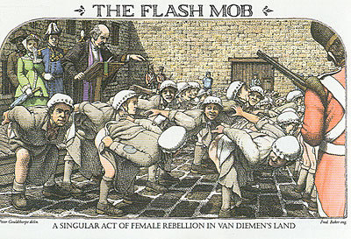
The middle finger up was Ancient Greek mentioned in the comedy “The Clouds” by playwright Aristophanes as an insult but also is a protective against 'The Evil Eye'.
There are plenty of others in various other cultures,Can't remember which one 'thumbing a lift' hand position is a killing insult but people have been run down by enraged car drivers because of it, the countries around the Med are particularily rich in them.
Edited November 1, 2011 by Grymm

Fox
- Old Twillian
- 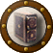
- 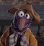
- Moderator

- 2,564 posts
- Gender:Male
- Location:Beautiful lush Devon, England
- Interests:Nautical history of the 16-18th centuries and living history based thereon.
Shooting pirates.
Posted November 1, 2011 · Report post
On 11/1/2011 at 6:32 AM, Grymm said:
Is anybody else thinking 'pencil sharpener'?
Quote
And here the parson is surely deliberating which one to stick his finger in first...
Ah, bottom humour. Now we've reached my level.

adam cyphers
- Plunderer
- 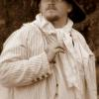
- Member

- 428 posts
- Gender:Male
- Location:hampton,va
- Interests:blacksmithing,tattoos,art in general,crafting things with my own two hands,many others...
Posted November 1, 2011 · Report post
its not a gesture but i know "shit breeches"is a period insult.

Grymm
- First Mate
- Member

- 281 posts
- Gender:Male
- Location:Chilterns UK
- Interests:Stuff
Posted November 1, 2011 · Report post
On 11/1/2011 at 10:45 AM, Foxe said:
And here the parson is surely deliberating which one to stick his finger in first...
Women convicts displaying their views on the parsons sermon and religeon generally... The lady in green trying not to piss herself laughing is a nice touch....OOOO Er Matron, apparently the Parson had a stroke.....baddam-tish!

Red_Dawn
- Ship's Master
- Member

- 120 posts
- Gender:Polly Wanna Cracker
- Location:Southern AZ
- Interests:A bit varied.
Posted November 1, 2011 · Report post
Thanks, guys!
Grymm said:
Which 2 finger salute? If you are thinking about the 'Archers salute' the idea that it's from Agincourt is a 1960/70 construct, as an offensive gesture it's certainly at least 17thC (His wife … Behind him forks her fingers. Sir John Mennes and J. Smith, Witts Recreations, 1640) but possibly as an adaption of The Cuckolds Horns, which is extending the fist with the forefinger and pinkie extended and the middle fingers doubled in( think the 'devil horns ROCK N FLIPPING ROLL!' symbol against your forehead), which implies that the person being insulted is a cuckold or their Missus does favours for sailors
Yeah, I was referring to the archers salute (i.e. the backwards peace sign). I've heard about the Horns, too, though I didn't know putting it on your forehead was a requirement.
Quote
Then there's the flicking the thumbnail with the teeth 'Biting your thumb' from Shakespear "I will bite my thumb at them; which is a disgrace to them, if they bear it."
Is that one obscene? Because that would make two scenes in Bon Voyage, Charlie Brown even funnier.
Quote
Mooning goes waay back too, Medieval
I forgot about mooning. It looks from the last two picture like it was chiefly a woman's gesture?

Grymm
- First Mate
- Member

- 281 posts
- Gender:Male
- Location:Chilterns UK
- Interests:Stuff
Posted November 1, 2011 (edited) · Report post
On 11/1/2011 at 5:48 PM, Red_Dawn said:
Thanks, guys!
I've heard about the Horns, too, though I didn't know putting it on your forehead was a requirement.
Think it's for more emphasis
"Then there's the flicking the thumbnail with the teeth 'Biting your thumb' from Shakespear "I will bite my thumb at them; which is a disgrace to them, if they bear it."
On 11/1/2011 at 5:48 PM, Red_Dawn said:
Is that one obscene? Because that would make two scenes in Bon Voyage, Charlie Brown even funnier.
Problem with hand gestures is that they do vary from country to country, like the 'talk to the hand, is rude socially in the US and UK but do the same to a Greek, especially with spread fingers and you've got a fight on your hands as it's s'posed to imply that they have a choice of 5 fathers or essentially calling their Mum a slapper/slut. Hitchhiking thumb or thumbs up for okay in UK US is a sexual insult in Greece and Sardinia
On 11/1/2011 at 5:48 PM, Red_Dawn said:
I forgot about mooning. It looks from the last two picture like it was chiefly a woman's gesture?
Just easier for women(And highlanders) pre mid 19thC as knickers aren't worn by most women if at all, jury is out but if they are worn it isn't a common thing and may be 'women of negotiable virtue' who adopt them first. The middle picture, with the painted face on a mooning arse, I think is a soldier judging by the 'blacked up' trumpeters flanking it and the 2 other blue uniformed men =o) Very squaddie humour, I remember doing summat similar during a stay in Grafenwöh when us British squaddies, as I was waaay back in the early 80s, came down for a joint exercise.
Edited November 1, 2011 by Grymm

Grymm
- First Mate
- Member

- 281 posts
- Gender:Male
- Location:Chilterns UK
- Interests:Stuff
Posted November 1, 2011 · Report post
Gobbing or spitting towards someone still is pretty offensive to most cultures.

Grymm
- First Mate
- Member

- 281 posts
- Gender:Male
- Location:Chilterns UK
- Interests:Stuff
Posted November 1, 2011 (edited) · Report post
Chapter of gestures from Rabalais GARGANTUA AND HIS SON PANTAGRUEL Book 2 ch19
http://www.gutenberg...0/1200-h/p2.htm
Some sound obscene but are never 'translated'.
Chapter 2.XIX.—How Panurge put to a nonplus the Englishman that argued by signs.
Everybody then taking heed, and hearkening with great silence, the Englishman lift up on high into the air his two hands severally, clunching in all the tops of his fingers together, after the manner which, a la Chinonnese, they call the hen's arse, and struck the one hand on the other by the nails four several times. Then he, opening them, struck the one with the flat of the other till it yielded a clashing noise, and that only once. Again, in joining them as before, he struck twice, and afterwards four times in opening them. Then did he lay them joined, and extended the one towards the other, as if he had been devoutly to send up his prayers unto God. Panurge suddenly lifted up in the air his right hand, and put the thumb thereof into the nostril of the same side, holding his four fingers straight out, and closed orderly in a parallel line to the point of his nose, shutting the left eye wholly, and making the other wink with a profound depression of the eyebrows and eyelids. Then lifted he up his left hand, with hard wringing and stretching forth his four fingers and elevating his thumb, which he held in a line directly correspondent to the situation of his right hand, with the distance of a cubit and a half between them. This done, in the same form he abased towards the ground about the one and the other hand. Lastly, he held them in the midst, as aiming right at the Englishman's nose. And if Mercury,—said the Englishman. There Panurge interrupted him, and said, You have spoken, Mask.
Then made the Englishman this sign. His left hand all open he lifted up into the air, then instantly shut into his fist the four fingers thereof, and his thumb extended at length he placed upon the gristle of his nose. Presently after, he lifted up his right hand all open, and all open abased and bent it downwards, putting the thumb thereof in the very place where the little finger of the left hand did close in the fist, and the four right-hand fingers he softly moved in the air. Then contrarily he did with the right hand what he had done with the left, and with the left what he had done with the right.
Panurge, being not a whit amazed at this, drew out into the air his trismegist codpiece with the left hand, and with his right drew forth a truncheon of a white ox-rib, and two pieces of wood of a like form, one of black ebony and the other of incarnation brasil, and put them betwixt the fingers of that hand in good symmetry; then, knocking them together, made such a noise as the lepers of Brittany use to do with their clappering clickets, yet better resounding and far more harmonious, and with his tongue contracted in his mouth did very merrily warble it, always looking fixedly upon the Englishman. The divines, physicians, and chirurgeons that were there thought that by this sign he would have inferred that the Englishman was a leper. The counsellors, lawyers, and decretalists conceived that by doing this he would have concluded some kind of mortal felicity to consist in leprosy, as the Lord maintained heretofore.
The Englishman for all this was nothing daunted, but holding up his two hands in the air, kept them in such form that he closed the three master-fingers in his fist, and passing his thumbs through his indical or foremost and middle fingers, his auriculary or little fingers remained extended and stretched out, and so presented he them to Panurge. Then joined he them so that the right thumb touched the left, and the left little finger touched the right. Hereat Panurge, without speaking one word, lift up his hands and made this sign.
He put the nail of the forefinger of his left hand to the nail of the thumb of the same, making in the middle of the distance as it were a buckle, and of his right hand shut up all the fingers into his fist, except the forefinger, which he often thrust in and out through the said two others of the left hand. Then stretched he out the forefinger and middle finger or medical of his right hand, holding them asunder as much as he could, and thrusting them towards Thaumast. Then did he put the thumb of his left hand upon the corner of his left eye, stretching out all his hand like the wing of a bird or the fin of a fish, and moving it very daintily this way and that way, he did as much with his right hand upon the corner of his right eye. Thaumast began then to wax somewhat pale, and to tremble, and made him this sign.
With the middle finger of his right hand he struck against the muscle of the palm or pulp which is under the thumb. Then put he the forefinger of the right hand in the like buckle of the left, but he put it under, and not over, as Panurge did. Then Panurge knocked one hand against another, and blowed in his palm, and put again the forefinger of his right hand into the overture or mouth of the left, pulling it often in and out. Then held he out his chin, most intentively looking upon Thaumast. The people there, which understood nothing in the other signs, knew very well that therein he demanded, without speaking a word to Thaumast, What do you mean by that? In effect, Thaumast then began to sweat great drops, and seemed to all the spectators a man strangely ravished in high contemplation. Then he bethought himself, and put all the nails of his left hand against those of his right, opening his fingers as if they had been semicircles, and with this sign lift up his hands as high as he could. Whereupon Panurge presently put the thumb of his right hand under his jaws, and the little finger thereof in the mouth of the left hand, and in this posture made his teeth to sound very melodiously, the upper against the lower. With this Thaumast, with great toil and vexation of spirit, rose up, but in rising let a great baker's fart, for the bran came after, and pissing withal very strong vinegar, stunk like all the devils in hell. The company began to stop their noses; for he had conskited himself with mere anguish and perplexity. Then lifted he up his right hand, clunching it in such sort that he brought the ends of all his fingers to meet together, and his left hand he laid flat upon his breast. Whereat Panurge drew out his long codpiece with his tuff, and stretched it forth a cubit and a half, holding it in the air with his right hand, and with his left took out his orange, and, casting it up into the air seven times, at the eighth he hid it in the fist of his right hand, holding it steadily up on high, and then began to shake his fair codpiece, showing it to Thaumast.
After that, Thaumast began to puff up his two cheeks like a player on a bagpipe, and blew as if he had been to puff up a pig's bladder. Whereupon Panurge put one finger of his left hand in his nockandrow, by some called St. Patrick's hole, and with his mouth sucked in the air, in such a manner as when one eats oysters in the shell, or when we sup up our broth. This done, he opened his mouth somewhat, and struck his right hand flat upon it, making therewith a great and a deep sound, as if it came from the superficies of the midriff through the trachiartery or pipe of the lungs, and this he did for sixteen times; but Thaumast did always keep blowing like a goose. Then Panurge put the forefinger of his right hand into his mouth, pressing it very hard to the muscles thereof; then he drew it out, and withal made a great noise, as when little boys shoot pellets out of the pot-cannons made of the hollow sticks of the branch of an alder-tree, and he did it nine times.
Then Thaumast cried out, Ha, my masters, a great secret! With this he put in his hand up to the elbow, then drew out a dagger that he had, holding it by the point downwards. Whereat Panurge took his long codpiece, and shook it as hard as he could against his thighs; then put his two hands entwined in manner of a comb upon his head, laying out his tongue as far as he was able, and turning his eyes in his head like a goat that is ready to die. Ha, I understand, said Thaumast, but what? making such a sign that he put the haft of his dagger against his breast, and upon the point thereof the flat of his hand, turning in a little the ends of his fingers. Whereat Panurge held down his head on the left side, and put his middle finger into his right ear, holding up his thumb bolt upright. Then he crossed his two arms upon his breast and coughed five times, and at the fifth time he struck his right foot against the ground. Then he lift up his left arm, and closing all his fingers into his fist, held his thumb against his forehead, striking with his right hand six times against his breast. But Thaumast, as not content therewith, put the thumb of his left hand upon the top of his nose, shutting the rest of his said hand, whereupon Panurge set his two master-fingers upon each side of his mouth, drawing it as much as he was able, and widening it so that he showed all his teeth, and with his two thumbs plucked down his two eyelids very low, making therewith a very ill-favoured countenance, as it seemed to the company.
Can you tell I'm avoiding doing proper work by looking this stuff up........ 'S far more interesting than George III household diet lists at Kew.
Edited November 1, 2011 by Grymm

peglegstrick
- Dread Pyrate
- Member

- 1,203 posts
- Gender:Male
- Location:Funston Ga
Posted November 1, 2011 (edited) · Report post
I remember when I was in the Navy we had a talking to.....apparently cheering for the bull in a bullfight in Mexico is not in good taste. Whod thunk it?
Damned drunken sailors!
Edited November 1, 2011 by peglegstrick

Jib
- Dread Pyrate
- Member

- 1,078 posts
- Gender:Male
- Location:Minneapolis, MN
- Interests:Piracy, stage combat, martial arts, reading, film, travel
Posted November 2, 2011 · Report post
The "fig" gesture appears to be the same as the "I've got your nose game" that was big with infants and very young children.

Red_Dawn
- Ship's Master
- Member

- 120 posts
- Gender:Polly Wanna Cracker
- Location:Southern AZ
- Interests:A bit varied.
Posted November 3, 2011 · Report post
On 11/1/2011 at 6:30 PM, Grymm said:
"Then there's the flicking the thumbnail with the teeth 'Biting your thumb' from Shakespear "I will bite my thumb at them; which is a disgrace to them, if they bear it."
On 11/1/2011 at 5:48 PM, Red_Dawn said:
Is that one obscene? Because that would make two scenes in Bon Voyage, Charlie Brown even funnier.
Problem with hand gestures is that they do vary from country to country, like the 'talk to the hand, is rude socially in the US and UK but do the same to a Greek, especially with spread fingers and you've got a fight on your hands as it's s'posed to imply that they have a choice of 5 fathers or essentially calling their Mum a slapper/slut. Hitchhiking thumb or thumbs up for okay in UK US is a sexual insult in Greece and Sardinia
Oh my!
The scenes took place in France after car accidents. At about 1:10 Snoopy bites his thumb (among other gestures) at the offending drivers.
Quote
Gobbing or spitting towards someone still is pretty offensive to most cultures.
Didn't realize that could be considered a gesture.
Quote
I remember when I was in the Navy we had a talking to.....apparently cheering for the bull in a bullfight in Mexico is not in good taste. Whod thunk it?
The nerve! Next thing you know, they'll tell you not to cheer on the bulls in Pamplona.

Grymm
- First Mate
- Member

- 281 posts
- Gender:Male
- Location:Chilterns UK
- Interests:Stuff
Posted November 3, 2011 (edited) · Report post
Snoopy cussed them out good, it's lucky he's using signs there coz it would've been X(R?) rated, also he does a version of 'The Cuckolds Horns' in that scene (1min 18) Erect wiggling fingers above ears. If he'd been in France f'real the driver behind would've shoved a baguette where the sun don't shine =o)
Edited November 3, 2011 by Grymm

John Maddox Roberts
- First Mate
- Member

- 272 posts
Posted November 3, 2011 · Report post
The first recorded case of mooning is from Flavius Josephus's "The Great Roman-Jewish War." Josephus says that in 66 AD a Roman soldier on the temple steps in Jerusalem turned his back, bent over and flipped up his tunic hem, exposing his buttocks to a large crowd of Jewish pilgrims in Jerusalem for a festival. This touched off a riot in which several thousand people were killed. They really knew how to have fun back in those days.

Red_Dawn
- Ship's Master
- Member

- 120 posts
- Gender:Polly Wanna Cracker
- Location:Southern AZ
- Interests:A bit varied.
Posted November 6, 2011 · Report post
On 11/3/2011 at 5:20 PM, Grymm said:
Snoopy cussed them out good, it's lucky he's using signs there coz it would've been X(R?) rated...
Well, Snoopy is an SOB.
Quote
...also he does a version of 'The Cuckolds Horns' in that scene (1min 18) Erect wiggling fingers above ears. If he'd been in France f'real the driver behind would've shoved a baguette where the sun don't shine =o)
Sounds like all I'd have to write is someone flashing a cuckold sign and hilarity ensues. Would it have a similar effect on the unmarried, with implications about either future spouses or their mothers?

landlubbersanonymous
- Plunderer
- Member

- 354 posts
- Gender:Not Telling
- Location:California, USA
- Interests:History, arts, collecting, reenacting
Posted November 6, 2011 · Report post
I got busted watching the Charlie Brown link by the little people.
The volume was low too. These creatures must have radar or somethin'.

